**Experiment-5 Implementing Static Routing using CLI**

ECP316 (Communication Networks)

**Aim:** Understanding and implementing static routing using CLI for simulating package transfer between different networks.

**Tools Used:** Cisco Packet Tracer

**Theory:**

Static routing is a manual network routing technique where predefined paths are set for packet forwarding. Using Command Line Interface (CLI), administrators configure static routes, ensuring controlled data transfer between networks. It is efficient for small networks, offering stability but requiring manual updates for topology changes.

### **Difference Between CLI and Normal Mode**

* **CLI (Command Line Interface):** A text-based interface where commands are entered manually for configuring network settings, making real-time changes, and troubleshooting.
* **Normal Mode (GUI - Graphical User Interface):** Provides a visual interface for configuration, often with drag-and-drop features, making it user-friendly but less flexible than CLI.

**CLI Commands:**

* **Press Enter** ; to start CLI
* **Router>enable** ; to enable the Router
* **Router#configure terminal** ; to configure
* **Route(config)#int <port>** ; selecting Port
* **Router(config-if)#ip add <ip> <mask>** ; to add ip address to port
* **Router(config-if)#no shut** ; to turn on the router port
* **Router(config-if)#exit** ; exit to normal configure
* **Router(config)#ip route <ip> <mask> <via ip>** ; add all possible paths

**CLI Commands:**

**Router 1:**

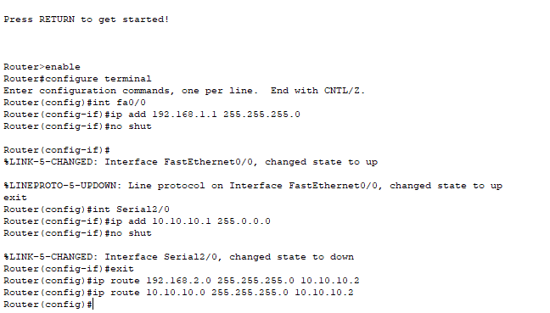

**Router 2:**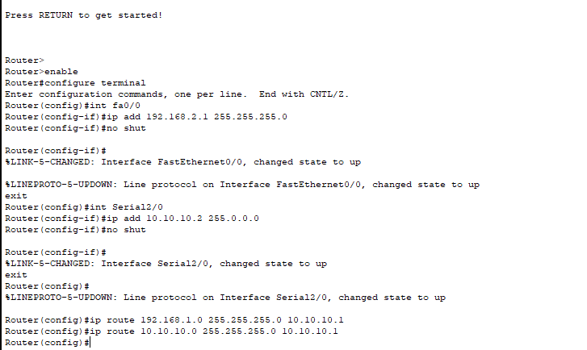

**Procedure:**

1. Open Cisco Packet Tracer application on computer.
2. Use PCs and give them IP addresses to the PCs and then configure using CLI Commands.
3. Use PT Switch and Router only as they’re already defined according to our use.
4. Use RJ45 Cables to connect the PCs and switches as according to the topology diagram. We can check the connections using ping in the command prompt of each PC.
5. Try sending mail from one PC to another and start simulation and observe.
6. Try Sending on different paths like 1st router sub-PC to 2nd router sub-PC etc..

**Connections:**

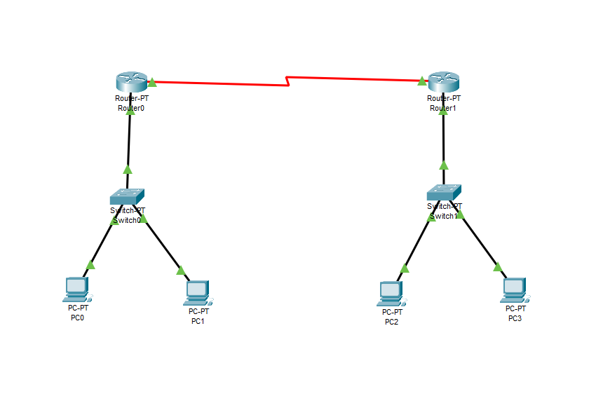

**Testing on Routes (Simulation):**

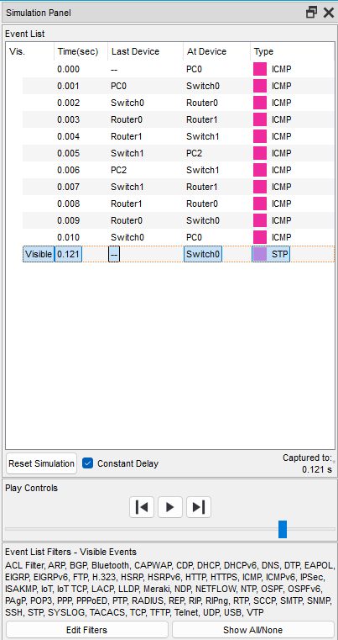

**Success:**

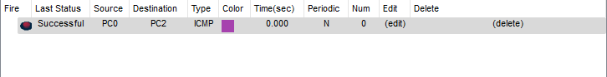

**Result:**

In this experiment, we implemented **static routing using CLI** to connect three routers and their PCs, ensuring end-to-end communication. Unlike GUI-based setups, CLI allowed precise manual route configurations, ensuring controlled packet transfer.

**Conclusion:**

1. Successfully implemented static routing using CLI for three routers and connected PCs.
2. Ensured each PC could communicate with every other PC through manually configured routes.
3. CLI-based configuration provided greater control and flexibility compared to GUI-based setups.
4. Static routing offers stability and security but lacks scalability and requires manual updates.
5. Packet transfer was precisely controlled, making it ideal for small networks.
6. Larger networks would benefit more from dynamic routing due to automatic route adjustments.
7. The experiment demonstrated the importance of efficient network design and manual route management for controlled environments.